Testing Documentation

**Q1. Using the ternary tree implementation of the Trie given in class, implement (12 marks) and test (6 marks) the public and private methods below to remove a key (value) from a ternary tree. Implement a Print method as well to show the ternary tree (5 marks). Main program/documentation**

|  |  |
| --- | --- |
| Case : 1 | |
| Input | Remove “abc”  The existing Trie is printed in the beginning of the screenshot |
| Output |  |

**Question 2**

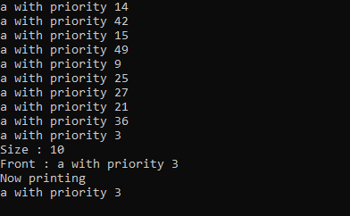

Here I tried to make a heap.

All the priority queues submitted are also printed in the beginging

Everything works perfectly. However, in print function it says null exception even when I have added if conditions, try-catch and everything. I can’t figure out for the life of me, why this is happening. Hence, this is the final print it shows. And the heap is made of generic type – priority queue which is made using random numbers.